

SCS 3250-041 FOUNDATIONS OF DATA SCIENCE

ANALYSIS REPORT: GLOBAL SUICIDE TRENDS
Apr, 14 2020

GROUP 1
Ekenedilichukwu Ani
Prabhdeep Jammu
Daniel Romney
Ulker Tas
Concetta Volpe

Table of Contents
INTRODUCTION 2
0. DATA CLEANING AND TRANSFORMATION 2
1. GENDER INFLUENCE ON SUICIDE 2
1.1 GENDER AND AGE 4
1.2 GENDER AND GENERATION 4
2. SUICIDE RATES FOR AGE AND DIFFERENT GENERATIONS 4
2.1 CORRELATION WITH AGE 5
2.2 1985 vs 2015 5
2.3 GENERATION VS SUICIDE RATES 6
3. SUICIDE TRENDS COMPARISON – CANADA vs GLOBAL 7
3.1 Suicide rates comparison for different age groups – Canada vs Global 7
3.2 Overall suicide trends comparison – Annual Canada vs Global 8
3.3 Annual % change in suicide rates – Canada vs Global 9
4. SUICIDE RATE ANNUAL CHANGES – HIGHEST INCREASES AND DECREASES 10
5. DEVELOPED VS DEVELOPING COUNTRIES 11
5.1 HDI attribute: 13
5.2 Breakdown by Continent: 14
/6. EFFECTS OF WEATHER MEASURES ON SUICIDE RATES 15
7. CONCLUSION 16
8. REFERENCES 17

INTRODUCTION
Our group decided to review and analyze suicide rates worldwide. The source we used for data is the dataset made available by World Health Organization (WHO) which covers data reported by various countries between the years of 1985 and 2016 and pulled from Kaggle, stored in master.csv file. In this report, we will summarize our approach with findings following a detailed data analysis by using Python.
To begin, we cleaned the data to pull the countries with the most fulsome reports, leaving us with 73 countries. Further details on how the data was cleansed and transformed is explained later in this report. We then analyzed the data by analyzing several of the attributes available in the dataset. There were several keys indicators we looked at when analyzing the data in more detail.
We started our analysis by focusing on the differences and similarities within the sex attribute of the dataset. Afterwards, we looked at the age attribute and how other attributes interacted with the age groups present in the dataset.
Being Canadian, we reviewed the suicide trends observed in Canada vs rest of the world in detail to understand major differences and overlaps. Additionally, we explored which countries had the largest increases and decreases in suicides rates over a ten-year span. We looked at these trends by sex and age to determine if there was any interesting information to be uncovered.
After comparing Canada vs rest of the world, we explored the suicide rates between developed and developing nations, looking at both the GDP and HDI attributes. We also investigated the full dataset and compared suicide rates to weather metrics to determine if this was also a key factor when looking at suicide rates by country than age. Since weather isn’t a part of the original dataset, we used an external dataset to source the information and join it with the suicide dataset.

0. DATA CLEANING AND TRANSFORMATION
When we looked at the data, the dataset was very well organized for the most part. We noticed that there were a lot of countries that had incomplete or discontinuous data. For example: some countries had very little suicides in one year (compared to population) and significantly higher suicides in the next year and then very little yet again. We assumed this was due to bad data collection practices.
Additionally, there are several countries that very low number of suicides. Because of the low number, a small increase is exaggerated in terms of percentages. Therefore, we also removed them from the dataset.
In order to get data prepared for analysis, we compiled a list of these countries and created a new dataframe which excluded the countries containing the ‘bad data’. The list of ‘bad countries’ have been listed in the notebook. There were several transformations applied to create new attributes for our analysis. The transformation applied has been described in detail in the relevant section.
For the weather, there was considerable cleanup required to use the raw data. The raw data has a lot of data in many rows based on weather stations across the world. We cleaned up this data to only extract maximum, minimum and average temperature and grouped by individual country. The result of this cleanup is stored in a filed called average_country_temperature.csv file, which is then used for the analysis.

1. GENDER INFLUENCE ON SUICIDE
Notebook reference: Section 1 Male vs Female.ipynb
In this section, we’ll focus on the sex attribute of the dataset. We’ll explore the global trends over the years between the two genders, as well as how they fare other attributes within the dataset.
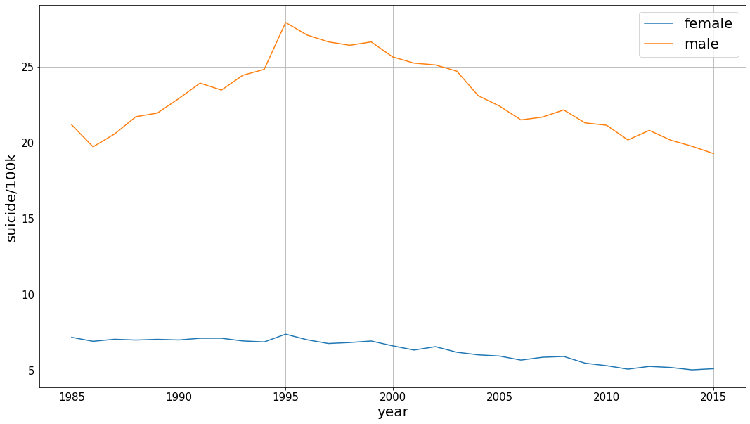
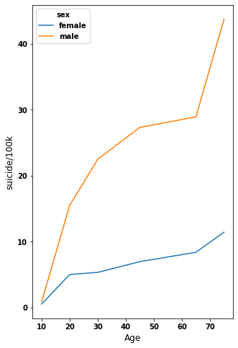
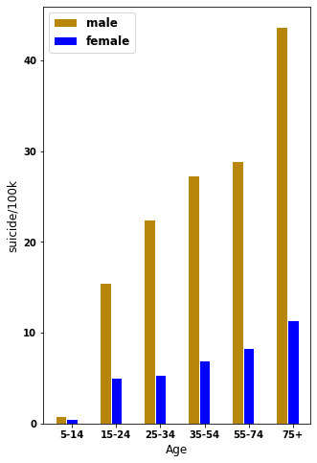
We started by grouping the data set by just Sex alone and taking the average of the suicide per 100,000 from all countries. We used this metric because it is a more standardized type of data and it would enable us to present more accurate result from the data as opposed to just using the suicide number’s column information as some countries have much more bigger populations than others. Figure 1.1 shows a graph of male vs female suicide rates over the years in the dataset
Figure 1.1 - Global suicide rates for Male vs female
Figure 1.2 - Male vs female suicide rates as per age
This graph shows a very telling picture. It shows us that there is a significant difference between male and female suicide rates globally. In fact, it shows us that men commit suicide at a rate of 3 to 4 times as much throughout all the two decades shown in the dataset.
This significant difference has been the subject of much research and articles over the years. According to a BBC article studying this subject, there are several factors for this difference. According to the article, men are less likely to reach out for help when dealing with mental health problems. Additionally, men are also more at risk of alcohol dependence and addiction which are used as unhealthy coping mechanisms for mental health problems. These two factors lead to the higher rates for men. Interestingly, the article states that suicide attempts for women (in US) are slightly higher than men. This means that American men choose more lethal ways when attempting suicide.

1.1 GENDER AND AGE
Exploring how these rates are affected by age for both genders, we’ll group the data frame by the age group and sex to find the mean of ‘suicides/100k pop' column for each group. From Figure 1.2, two observations can be made: 1) The suicides rates are positively correlated with age for both genders, and 2) The difference between male and female rates becomes more extreme with age. There’s almost a steady straight-line relation between suicide rates and age for women, whereas the slope for men’s is a lot steeper and becomes very steep for 75+ age group. Therefore, the difference between men and women’s suicide rates increase with age.

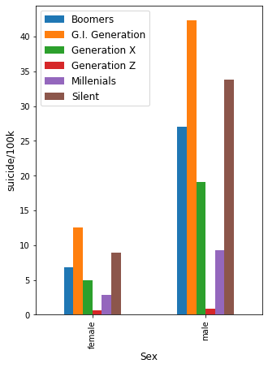
1.2 GENDER AND GENERATION
Next up we went ahead to analyse the data frame by looking at it from the perspective of different generations to see if we could identify any difference among the generations of humans.
From figure 1.3, we can see that for both male and female the G.I. Generation had the highest suicides per 100,000 of population.
When looking at the averages for all countries based on generations of human beings. The results for males still greatly outnumbered that of females on average, when comparing results for both genders from all generations.

2. SUICIDE RATES FOR AGE AND DIFFERENT GENERATIONS
Notebook reference: Section 2 Generation vs Suicides.ipynb
Figure 1.3 - Suicide rates for different generation - M vs F
Within the given dataset, there’s a column called age which provides us with the age of the victims at the time of their suicide. This column provides us with six age ranges: '75+ years', '55-74 years', '35-54 years', '25-34 years', '15-24 years' and '5-14 years’.

2.1 CORRELATION WITH AGE
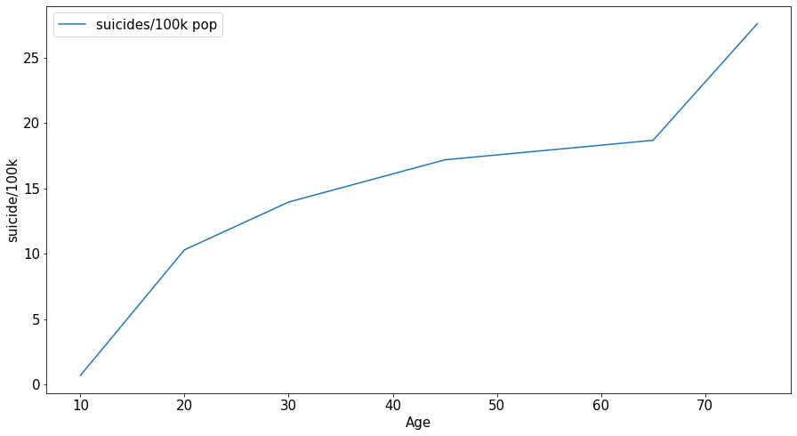
In this section we wanted to start off by determining if there was any correlation between age and suicide rates. Unfortunately, the age column is of type object which made it hard to determine correlation. Therefore, we created a function called age_to_int which converted the age range into an integer based on the mean of each range. For age range ‘75+’ we chose 75 as the mean. After grouping by this new column (age_int) and year, the relationship between age and ‘suicides/100k is shown in figure 2.1. There’s a strong positive correlation between age and suicide. That is, as age increases, the rates increase as well.

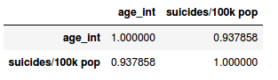
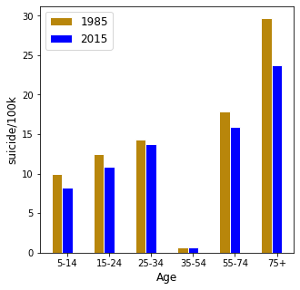
The .corr() method is a method in pandas library that can measure the correlation between two columns in a dataframe. Using this method on the grouped dataframe reveals a very strong positive correlation. As you can see in figure 2.2, the correlation coefficient is 0.94 which implies a strong positive relationship between the two variables. One more interesting thing to note is that the increase is occuring at a decreasing rate except for the very high ages where the slope becomes steeper and the rate shoots up. This means that the suicide rates are increasing at a decreasing up until the age range of ‘55-74’ and then it shoots up dramatically for the ‘75+’ range
Figure 2.1 - Age vs suicide/100k plot
Figure 3.2 - Correlation matrix for age vs suicide rates

2.2 1985 vs 2015
The dataset displays data about suicide rates from 1985 to 2015. Therefore, we wanted to see if there were any major differences between the first year and the last year in terms of the age groups. Figure 2.3 shows the ‘suicides rates/100k’ plotted per age group for 1985 and 2015
The graph shows that there isn’t much difference between the two years, except for the 75+ age group. In 2015, the suicide rates for 75+ age group are significantly lower compared to 1985. Although it may not be definitive proof, but this shows that the world has gotten better at taking care of the elderly when it comes to suicide.
Figure 2.3 - 1985 vs 2015 suicide rates by age groups

2.3 GENERATION VS SUICIDE RATES
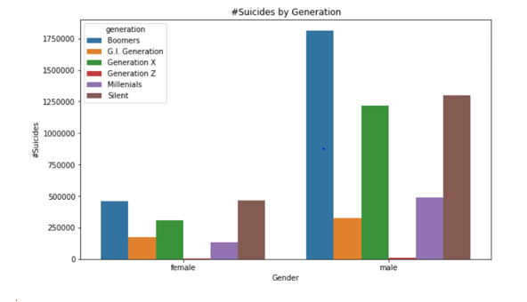
In this section, we`ll review the suicide trends experienced by different Age groups and generations as defined in the dataset. First, we determined the breakdown of the total number of suicides reported by age and generation. After pulling the total sum of suicides reported by age and generation, we investigated the data further to provide more detail for our analysis. The first goal was to determine how many of the total suicides represent Females vs. Males for each generation category.
Figure 2.4 - M vs F rates based on generation

In line with the findings of Section 1, Figure 2.4 shows that Male suicide rates are higher than Female for every generation with no exception. For both Male and Female, we see that highest number of suicides is experienced by Boomer generation closely followed by those in the Silent generation, and then Generation X.
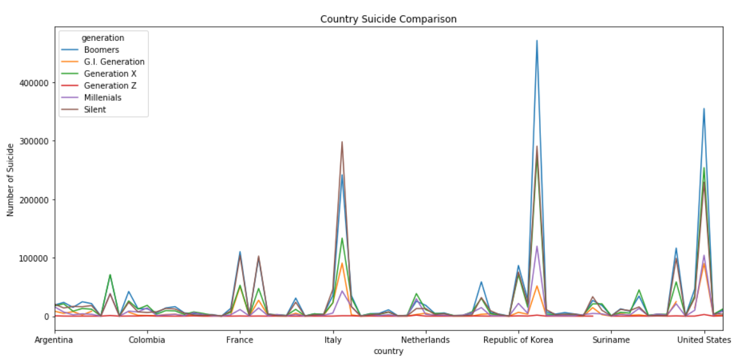
Figure 2.5 - Suicide rates for countries based on generation
Figure 2.5 reflects that certain countries have higher rates of suicide by generation than others. One of the top 10 countries with high suicide numbers is Republic of Korea. According to the WHO the suicide rate in South Korea is the 10th highest in the world. As reflected in the figures the highest generation for suicide is amongst the elderly. The reason provided for this is because aging parents do not want to feel like they are a financial burden on their families, in a culture where tradition is for the family to take care of their elderly parents.

3. SUICIDE TRENDS COMPARISON – CANADA vs GLOBAL
Notebook reference: Sections 3 & 4 Canada vs Global and Annual Change.ipynb
In this section, we reviewed the suicide trends experienced in Canada vs Global in detail to understand major differences and similarities. The first step is to separate dataset into two dataframes as shown below:
Dataset #1: Canada only
data_Canada=master_good.loc[master_good['country']=='Canada']

Dataset #2: All countries excluding Canada
data_Global=master_good.loc[master_good['country']!='Canada']

3.1 Suicide rates comparison for different age groups – Canada vs Global

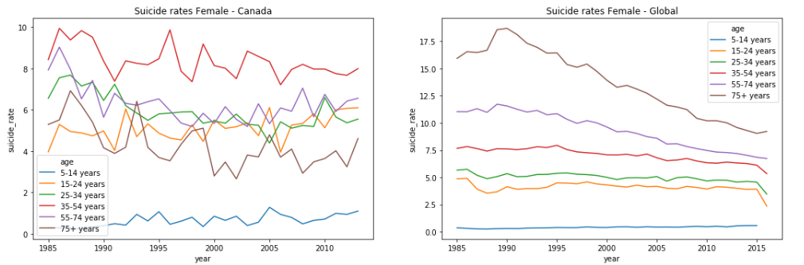

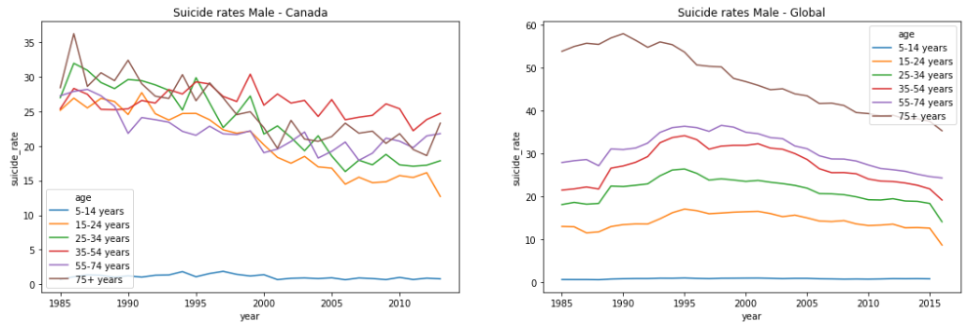
As shown in Figure 3.1, Canadian female suicide rates have been the highest for the age group 35-54 years consistently since 1985 whereas globally, the highest suicide rates have been for the age Group of 75+ years. In fact, as opposed to the global trends, females in Canada aged 75+ years end commit suicide less often in comparison to all other adult groups (excluding the age group 5-14 years). In Canada, the age group of 75+ years has the lowest suicide rates among female adults (in recent years). Globally, all age groups (excluding 5-14 year) show a downward trend since 1990 in terms of suicide rates. The main difference between the global and Canadian data is that the global trends show that suicide rates increase as the age goes up for females, which is not the case for Canada. The same conclusion is also valid for males as shown in Figure 3.2 for cumulative suicide rates for Canada vs rest of the world.
Figure 3.1 - Suicide trends for Females – Canada vs Global
Figure 3.2 - Suicide trends for Males – Canada vs Global
As is the case with women, Figure 3.2 shows that Male suicide rates have been the highest for the age group 35-54 years since about 1997. Additionally, the graph shows that there is steady decrease in suicide rates for all age groups for both Canada and the world (excluding 5-14 age group).
Statistics Canada analysis confirms that it is a persistent trend in Canada for many years that the middle-aged Canadians end their lives through suicide at a higher rate in contrast to the global trends. Refer to the website linked below for all Canadian suicide facts and highlights. As the data source is not openly available for Canadian suicide details, this dataset has not been included in the scope of this analysis.

3.2 Overall suicide trends comparison – Annual Canada vs Global
After looking at the trends for different age groups, this section will summarize the overall trends combined for all age groups to see how suicide rates change over the years for Canadians and the rest of the world. Again, the graphs are built individually for female and male dataset as they show distinct behaviour.
# Grouped Canada dataset
C1=df_Canada.groupby(['year','sex'])['suicides_no','population'].sum()
C1['suicide_rate']=round((C1.suicides_no/C1.population)*100000,2);C2=C1.reset_index('sex')

# Grouped Global dataset
G1=df_Global.groupby(['year','sex'])['suicides_no','population'].sum()
G1['suicide_rate']=round((G1.suicides_no/G1.population)*100000,2);G2=G1.reset_index('sex')

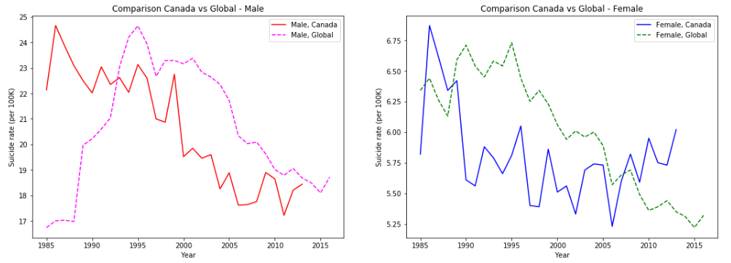
Figure 3.3 - Annual suicide rate trends – Canada vs Global, Female & Male
Figure 3.3 clearly shows that Canadian suicide rates have been going down steadily since 80s for Males, whereas for global data, this downward trend started in 1995. Additionally, suicide rates have been consistently lower for Canadian men compared to the world, although that gap has been closing in recent years.
For Females, the suicide rates have been decreasing steadily since 1980s, however we see that there is an uptick since 2006, in contrast to the declining trend globally. In fact, after 2008, rates for Canadian women are higher compared to the world. Global News covered this topic specifically as part of the article linked below. Statistics Canada confirms the trend showing higher increase in suicide rates for female in comparison to male for last 15 years. There may be multiple contributors to this trend such as increasing mental health cases for women, higher number of single moms and increased pressure on women with combined work and house responsibilities along with childcare and parent-care.

3.3 Annual % change in suicide rates – Canada vs Global
For this analysis, we first calculated ‘annual_change’ for year-over-year suicide rate changes experienced in Canada vs Global data in terms of percentage of previous year’s suicide rate.
# annual_change added to Grouped Canada dataset
C3=C1.assign(annual_change=C1.groupby('sex')['suicide_rate'].apply(lambda x:x.diff().fillna(x)));C4=C3.reset_index('sex').drop(['1985'])

# annual_change added to Grouped Global dataset
G3=G1.assign(annual_change=G1.groupby('sex')['suicide_rate'].apply(lambda x:x.diff().fillna(x)));G4=G3.reset_index('sex').drop(['1985'])

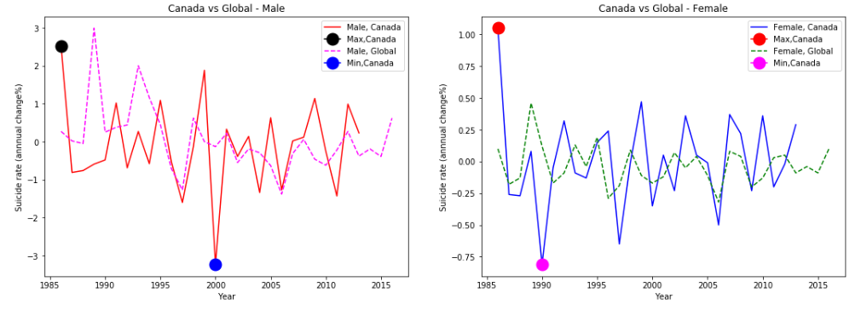
Figure 3.4 - Annual change in suicide rates – Canada vs Global, Female & Male
We see in Figure 3.4 that for both Male and Female suicide rates, the biggest annual increase in suicide rates came between years 1985 and 1986. Highest decrease in suicide rates in Canada was observed between years 1999 and 2000 for Males and between years 1989 and 1990 for Females.

4. SUICIDE RATE ANNUAL CHANGES – HIGHEST INCREASES AND DECREASES
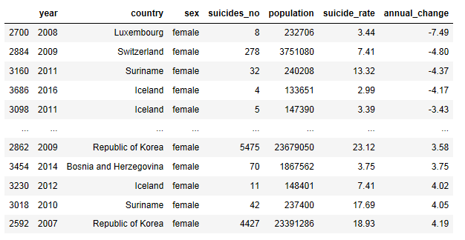
For this analysis, we only focused on the last 10 years and included all the countries in the analysis. First, we grouped our main master_good dataframe by year, country and sex columns and then added suicide_rate and annual_change parameters. As we decided to only focus on last 10 years, we only took the years where year value is bigger or equal to 2007. Figure 4.1 and 4.2 show the countries found.
Figure 4.1 - Suicide rate change % for females

Overall=master_good.groupby(['year','country','sex'])['suicides_no','population'].sum()
Overall['suicide_rate']=round((Overall.suicides_no/Overall.population)*100000,2)
O1=Overall.reset_index()
O2=O1.assign(annual_change=O1.groupby(['country','sex'])['suicide_rate'].apply(lambda x:x.diff().fillna(x)));O3=O2.loc[O2['year']>=2007]

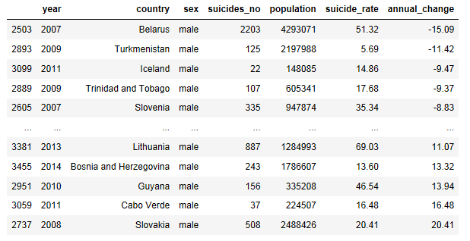
Figure 4.3 shows graphs that are shown specific to those countries with highest annual decrease and increase in suicide rates. For detailed analysis, only Iceland, Belarus and Lithuania are selected and shown below. Iceland shows up in both highest annual increase and decrease for both genders. Belarus and Lithuania are selected as they have significantly high suicide rates in comparison to other countries in the list.
Figure 4.2 – Suicide rate change % for males

For Belarus suicide rates, many studies indicate that increases in alcohol consumption in the country (esp. strong spirits) correlate with an increase in number of suicides. The most famous study on this correlation was conducted by Yury Razvodovsky.

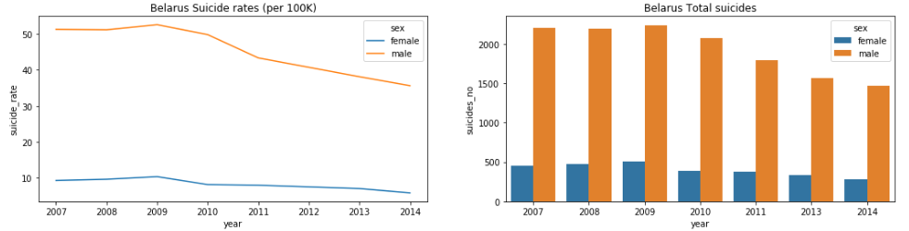
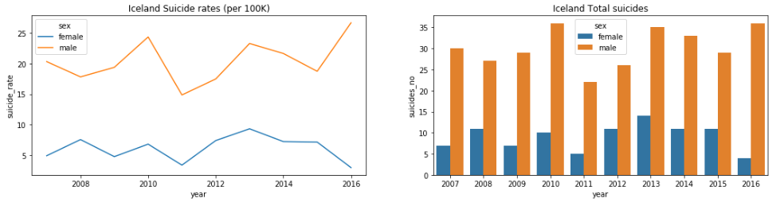
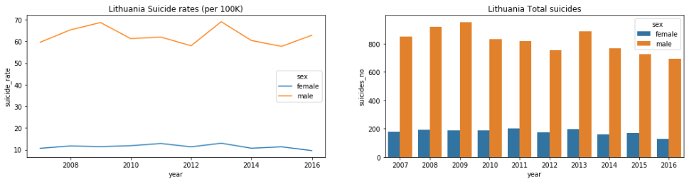
The low level of religiousness in Belarus is also claimed to affect the suicide numbers according to many. Belarus is one of the most atheistic countries worldwide. The article title ‘Why do Belarusians commit suicide’ provides a comprehensive overview of suicide rates in Belarus. This article also draws attention to the similarities between Lithuania and Belarus in terms of their common history and tendencies.
Figure 4.3 - Suicide rates for Belarus, Iceland and Lithuania

For Iceland, the possible reasons for the fluctuations could be because of the low number of suicides in Iceland in general. Due to the low numbers, a few extra suicides can make a huge difference.

Please also note the detailed graphs make it visible that Bosnia H. only reported suicides for years 2011 and 2014. Similarly, Cabo Verde reported suicide statistics only for year 2011. Hence, the names of those countries are removed from the final countries_highest list due to lack of their data reporting.

5. ROLE OF ECONOMICS IN SUICIDES – DEVELOPED VS DEVELOPING COUNTRIES
Notebook: Section 5 Developed vs Developing Countries.ipynb

In this section, we’ll be exploring the suicide rates between developed and developing countries. The first challenge is to determine what criteria will be used to define a developed vs developing country. A developed country is a country that has an advanced, mature economy and infrastructure. This is led to believe to a higher standard of living and prosperity for it’s citizens. On the other hand, a developing country is one that has an under-developed economic system and low to mediocre infrastructure, thus providing a lower quality of life to it’s citizens.
There are several metrics to measure how developed a country is: income inequality, GDP per capita, average income. Since we have one of the metrics available to us in the dataset (GDP per capita), we will be using this to classify developed vs developing countries. There is no concrete rule about a cut-off level for GDP per capita in terms of determining how developed a country is, but a rule of thumb is anything above $20,000 of GDP per capita is considered a developed country. Of course, there are several other factors that go into determining the eligibility, but this is a quick way that we’re going to use for our analysis.

Adding ‘Type’ attribute: After loading the dataset into a dataframe, we will add a new column called ‘Type’. This attribute tells us whether the country specified in the column is developed or developing.
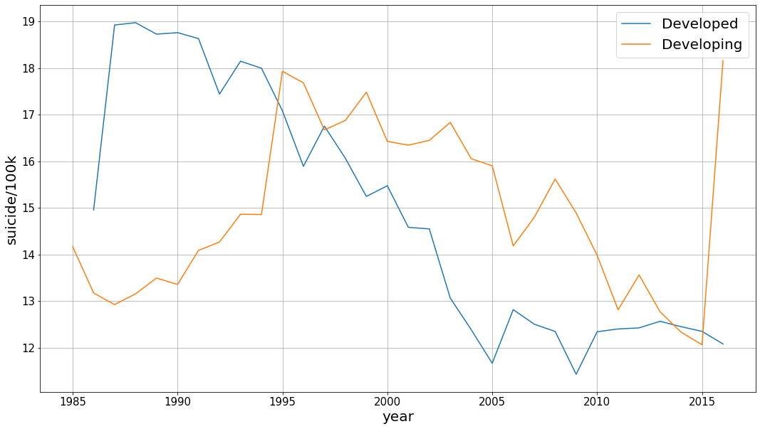
This line works almost like an if/else statement where anything above with a GDP per capita above 20,000 is assigned Developed and Developing otherwise.
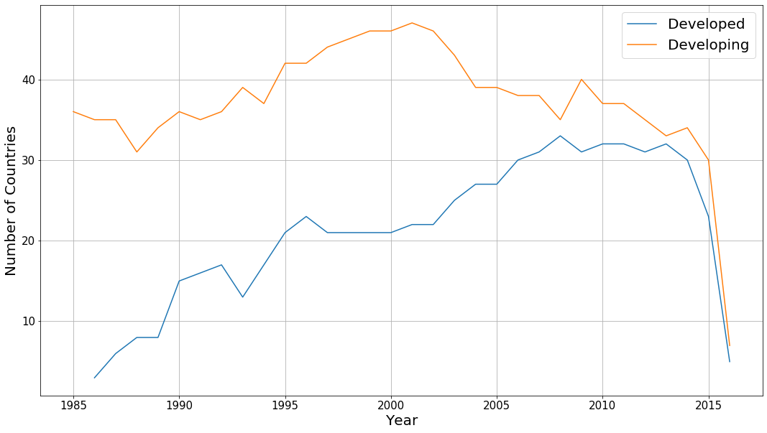
The first task is to see the suicide rates between the developed and developing countries over the years. In order to do this from the main dataframe, we needed to group the dataframe by year and by country because the data is split up into multiple rows (by age). After the grouping, we can make a dataframe based on the mean of the 'suicides/100k pop' column values.
Figure 5.1 - Developed vs Developing nations suicide rates (per 100k)
After the grouping, we can plot our dataframe with matplotlib (Figure 5.1). There are three interesting things to note here. First, the suicide rate for developed countries is way higher than developing countries in the first few years. It is almost twice as much as the developing countries. Secondly, as the time moves forward, the suicide rate for developing countries increases while the suicide rate for developed countries decreases, intercepting at around 1994. Lastly, there’s a sudden spike in 2005 (and a subsequent downturn) followed by a trend where the rates start increasing after about 2009 for developed countries. Additionally, there’s a sharp increase for developing countries after 2015.
Figure 5.2 - Count of countries in developed vs developing group per year
To address the first note, we decided to gather the number of countries for each year that fall into each category. To do this, we grouped the dataframe by year, country and Type and get a count for the number of countries in each type by year. A plot of the count is shown in figure 5.2.
Figure 5.2 shows that the number of countries in developed countries is significantly lower compared to developing countries. It’s very possible that initially (around 1985), a lot of countries didn’t meet the criteria for a developed country, which is why the count for them is so low. The count increases dramatically over time, so a lot more countries are counted as a developed country as time goes on. There is also a huge drop in the number of countries after 2015. This shows us that the data for 2016 is faulty as it contains relatively fewer countries compared to previous years. Therefore, we’ll be ignoring this outlier.
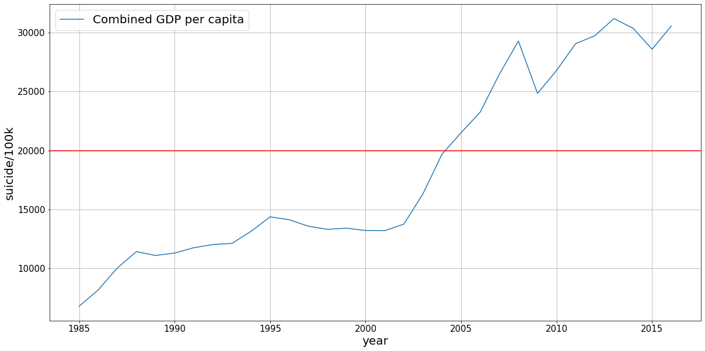
As you can see from the graph in Figure 5.3, the combined GDP per capita has steadily increased over 1985 onwards which means a lot more countries end up meeting the criteria of being developed. (indicated by the horizontal red line).
As observed earlier, a trend can be noticed after 2008 for developed countries where the suicide rates begin to increase over time, after a period of significant decrease in the 2 decades prior to that. 2008/09 was the beginning of the financial crisis that led to the Great Recession. This time saw the life savings wiped for a lot of people and many developed countries were especially hit hard. It’s very possible this is what led to the increasing suicide rates after 2008 among developed countries.
Figure 5.3 - GDP per capita of world per year

5.1 HDI attribute:

Human Development Index (HDI) is a metric used by United National Development Programme to measure the level of human development in each individual country. The index consists of three components: life expectancy, education and per capita income. Scoring high in these components results in a high HDI.
Within our dataset, we have a column called HDI that measures the HDI for each country for each year. Checking for null values for the HDI column, we can see there are quite a lot of empty values.
There are 15,480 null rows for the ‘HDI for year’ column, which gives us about 8000 rows to work with. First step is to make a dataframe that doesn’t contain any null values for the ‘HDI for year’ column. A new dataframe can be created by grouping the HDI dataframe by year and country and including the mean for ‘suicides/100k pop’ and ‘HDI for year’ columns.
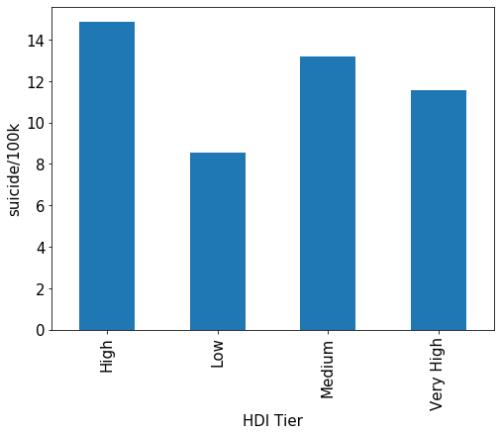
Next step is to classify the HDI column into tiers of very high (0.90-1.00), high (0.80-0.89), moderate (0.55-0.79) and low (less than 0.55). The classification can then be done with the classify_hdi function. After applying the function on every row, a new column can be made with the new tiers and then the mean suicide rate of each tier can be plotted. (Figure 5.4)
From the plot, there might be a general negative linear relation between HDI and suicide rates (i.e.: the higher the HDI, the lower the rate), but the low HDI tier having the lowest rate disproves that. Upon investigating further for the number of values in each category, we found that the value counts for low category are significantly lower compared to others. Since it has such low numbers, we’ll ignore this category as it can’t be used for any conclusions. This means that the linear relation between HDI and suicide rates is maintained.

5.2 Breakdown by Continent:
Figure 5.4 - Suicide rates by HDI tier
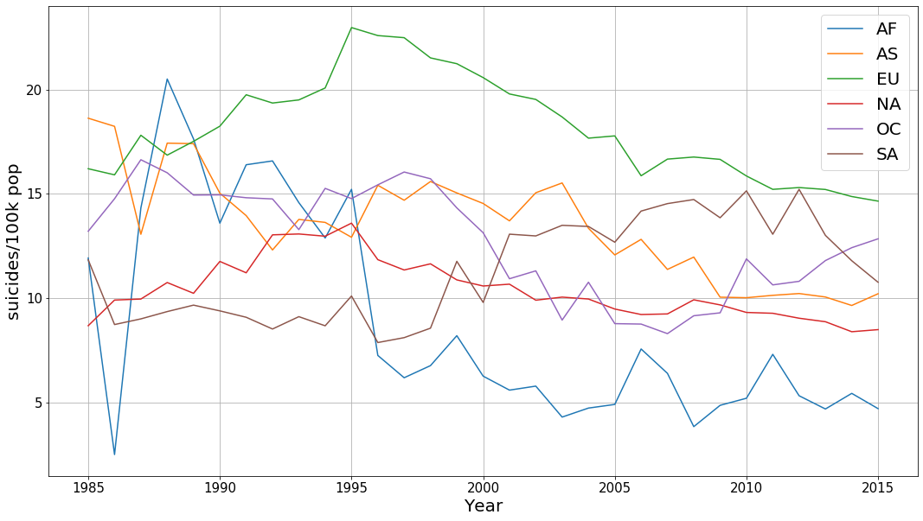
Since we have the breakdown by country, we can get a breakdown of suicide rates by continent as well. In order to do this, we need to make a new column called ‘continent’ and map the country names to the corresponding continent. In order to do this, we used a python library called pycountry-convert (https://pypi.org/project/pycountry-convert/).
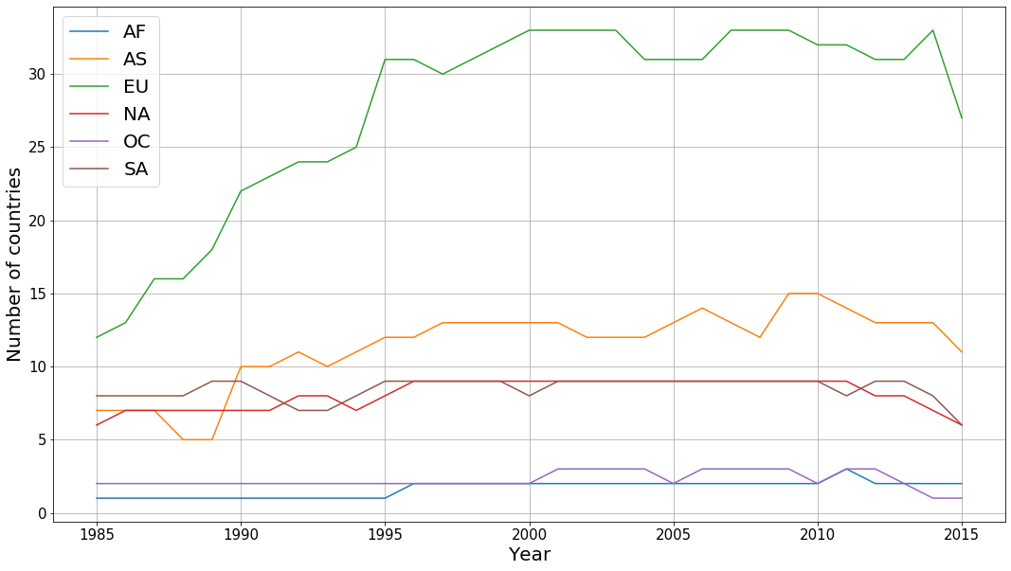
This involved a two-step process. The first step is to convert each country to a 2-letter code with the country_name_to_country_alpha2 method. The next step is to convert the 2-letter country code to a 2-letter continent code with the country_alpha2_to_continent_code method. This process was defined in the country_to_cont function and applied to every column.
Figure 5.5 - Suicide rates by Continent
/Two things jump out from Figure 5.5: The rate for Africa (AF) has a very high variance and a rate of the lowest rate in the later year and the rate for Europe is consistently higher compared to other continents and begins a period of gradual decline after 1995. /If we plot the number of countries in each year by continent (Figure 5.6), we can see that the number for Africa is very low. This means the variability of suicide rate in each country within Africa has a large effect on the overall variability for Africa. Additionally, Africa has 54 countries and only one to two of them are represented in this dataset. It’s very possible that only countries providing the data are the ones with the lowest suicide rates, resulting in a false representation.
Figure 5.6 - Count of countries in each continent

/6. EFFECTS OF WEATHER MEASURES ON SUICIDE RATES
Notebook reference: Section 6 Weather vs Suicides.ipynb
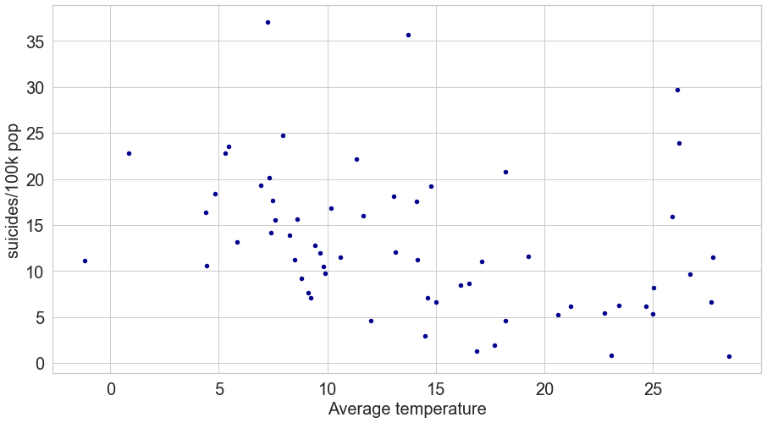
Some studies have been centered around the effects of weather metrics, such as temperate, wind, sunshine on behavioural aspects of humans, including suicides⁷⁻¹². We found it interesting to compare our global dataset of suicide rates to weather metrics and see if there are some patterns that could be studied further. The first step of this analysis is to find a reliable data set for weather, which was quite challenging given the vast amount of unstructured data and poor capture quality. It was finally extracted from a slice of 2017 data of NSDC. Low, High and Average temperatures per country were calculated from 34,854,601 data readings from stations across the globe (219 different countries) during that year. And those readings were used to further enrich the suicides data frame.
Figure 6.1 - Average temperature vs Suicide rate for 2013
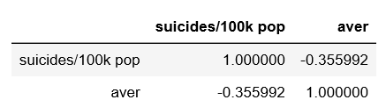
Considering the weather data is contained within large files, we decided to use just one year for the analysis. The weather data imported is from 2013 in order to compare it to the suicide data from 2013. We chose 2013 because that is the latest year which contains Canadian suicide data. After merging suicide data with the weather data based on the country name, we plotted the relationship between the average temperature and ‘suicides 100/k pop’ (Figure 6.1)
As you can see in the graph, there’s a moderate negative correlation between average temperature and suicide rates. With that said, this relationship seems to break up at about 25C, after which there are several cases of high suicide rates. Using the .corr() method, figure 6.2 shows the correlation coefficient. There’s a moderate correlation present as evidenced by the -0.36 coefficient.
Figure 6.2 - Correlation coefficient for suicide rates vs average temperature
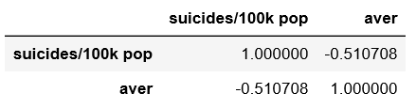
As observed earlier, the relationship seems to reverse at about 25C. We created a new dataframe that contains temperatures below 25. Using .corr() method again, figure 6.3 shows the correlation for
Figure 6.3 - Correlation coefficient for suicide rates vs average temperature below 25C
temperatures below 25C. As suspected, there’s a stronger correlation (-0.36 vs -0.51) when temperatures above 25 are absent. 25C seems to be the cut-off line for 2013.

7. CONCLUSION
Throughout this report, we explored the WHO dataset on global suicide rates. Throughout the report, we used different attributes within the dataset, such as gender, age, GDP and HDI to analyze the data. We also created new attributes from existing attributes by classifying HDI data and GDP per capita to determine developed vs developing countries. We also used external data to find correlation between temperature and suicide rates.
Through our analysis, we found that:
- Men commit suicide at a significantly higher rate compared to women and this phenomenon is observed globally.
- Age has a strong positive relationship with suicide rate. That is, the rate increases with age.
- HDI has a moderate negative correlation with suicide rate.
- Europe has consistently had the highest suicide rates compared to other continents.
- There’s a negative correlation between temperature and suicide rates up until 25C. After 25C, the rates increase.

8. REFERENCES
We linked various articles and webpages throughout the report in addition to the referenced listed below.
7. Popoli G, Sobelman S, Kanarek NF. Suicide inthe State of Maryland, 1970-80. Public HealthReports 1989;104:298-301
8. Massing W, Angermeyer MC. The monthly andweekly distribution of suicide. Soc Sci Med1985;21:433-41.
9. Araki S, Murata K. Suicide in Japan:Socioeconomic effects on its secular and seasonaltrends. Suicide & Life-Threatening Behavior1987;17:64-71
10. Maes M, Cosyns P, Meltzer HY, et al.Seasonality in violent suicide but not in nonvio-lent suicide or homicide. Am J Psychiatry1993;150:1380- 85
11. Kok LP, Tsoi WF. Season, climate and suicide inSingapore. Medicine, Science & the Law1993;33:247-52
12. Kevan SM. Perspectives on season of suicide: Areview. Soc Sci Med 1980;14D:369-78

https://www.bbc.com/future/article/20190313-why-more-men-kill-themselves-than-women
https://worldpopulationreview.com/countries/suicide-rate-by-country/
https://www150.statcan.gc.ca/n1/pub/82-624-x/2012001/article/11696-eng.htm
https://globalnews.ca/news/4274136/suicide-rates-women-men-canada/
https://www.researchgate.net/publication/26860958_Alcohol_and_suicide_in_Belarus
https://odb-office.eu/policy-briefs/why-do-belarusians-commit-suicide
https://www.ncdc.noaa.gov/data-access/land-based-station-data/land-based-datasets/global-historical-climatology-network-ghcn

